**Lab Practical #09:**

Implement the various network protocols - FTP

**Practical Assignment #09:**

Implement the application protocol - FTP using packet tracer.

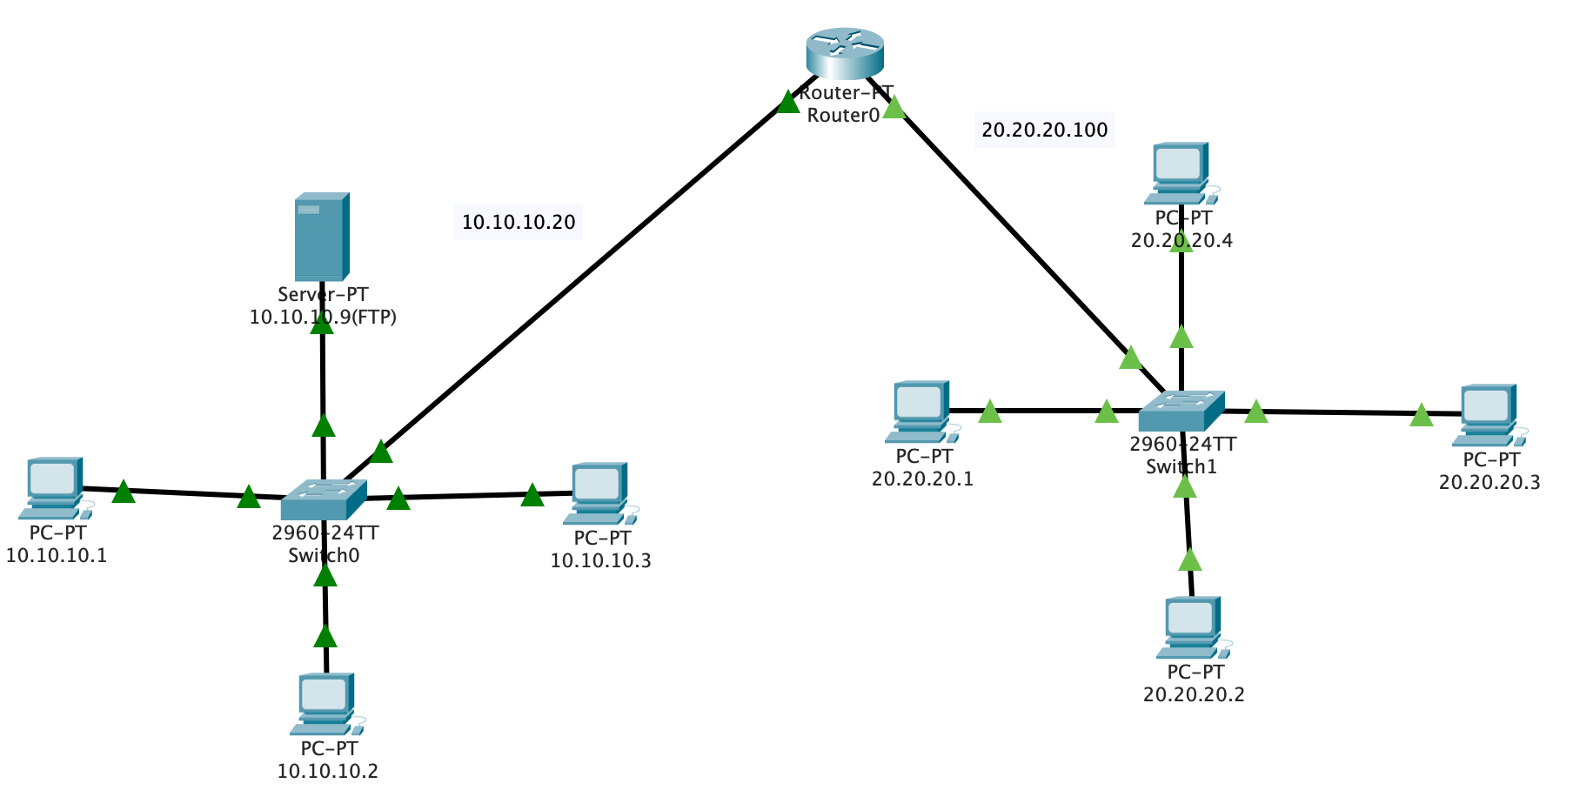

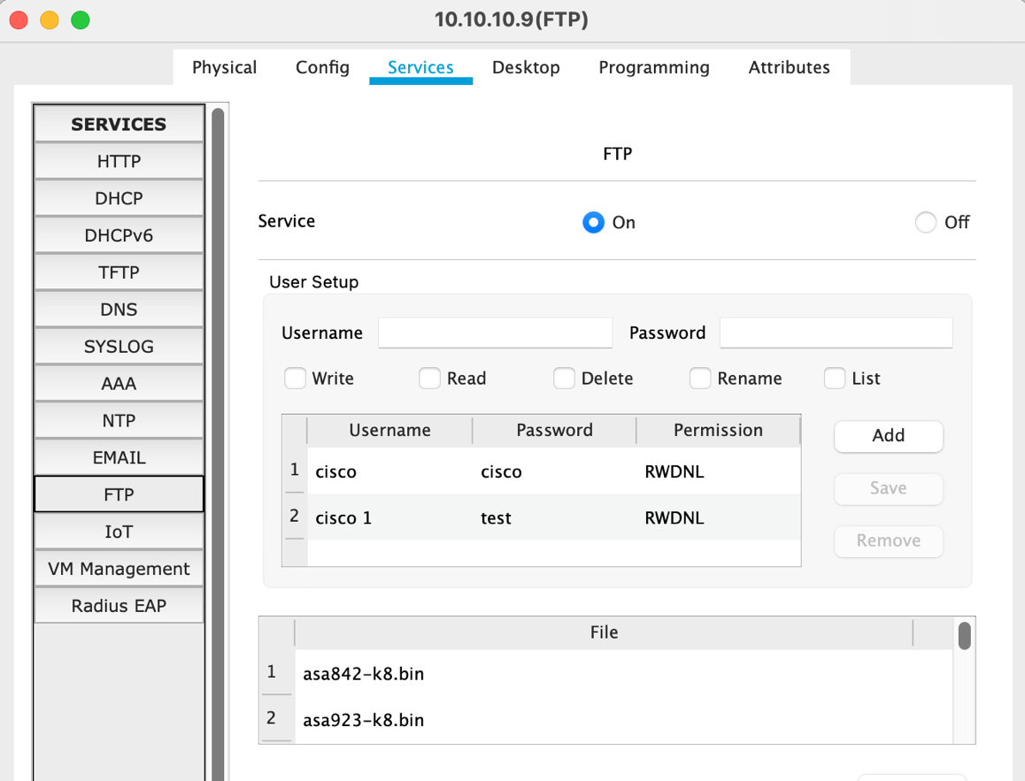

**FTP Configuration**

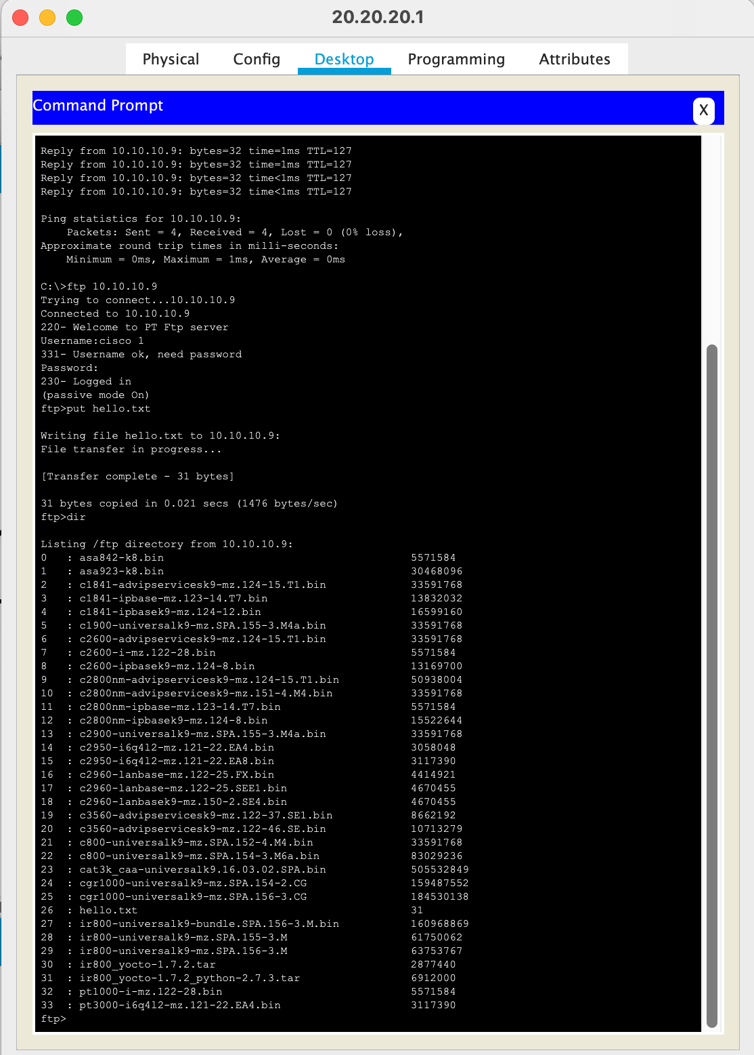

**Put file on FTP server from 20.20.20.1**

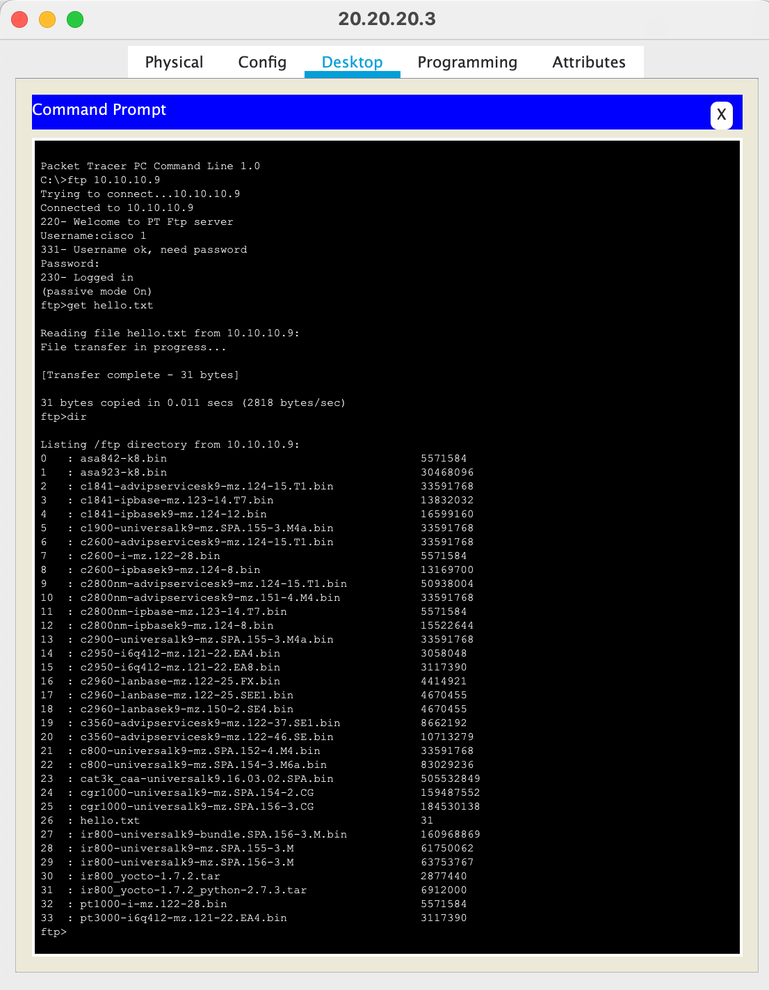

**Get file From FTP server on 20.20.20.3**

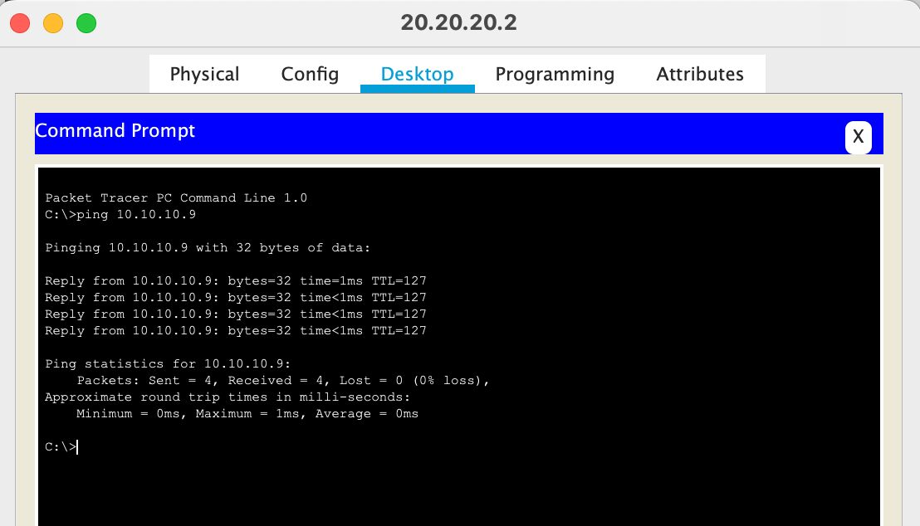

**Ping from 20.20.20.2 to 10.10.10.9 (FTP Server)**